**Guidelines for Data Visualization and Analysis Project**

**About the Project:**

In this project, you will be working with a dataset from the Superstore, aiming to answer 30 scenario-based questions through data visualisation and analysis. Your objective is to select the best chart for each question, explain your choice. This project will showcase your proficiency in data visualisation, critical thinking, and effective communication.

**Skills Required:**

* Proficiency in data visualisation concepts and techniques.
* Familiarity with Tableau or a similar data visualisation tool.
* Strong analytical and problem-solving skills.
* Ability to choose appropriate charts based on data characteristics and question requirements.
* Clear and concise communication skills.

**Deliverables:**

* A Google document containing solutions to the scenario based questions including the screenshot of relevant chart picked for each scenario, presented in a concise and well-structured format. Make sure to provide explanations that highlight your problem-solving skills.

**Rubrics for Assessment:**

Question Responses:

* Accuracy and completeness of answers for all 30 questions.
* Clear and concise explanations that address the question's context.

Chart Selection and Explanation:

* Thoughtful rationale for choosing specific chart types.
* Justification based on data characteristics, context, and communication goals.

Creative Enhancements:

* Effective use of creative elements to enhance visualisation quality.
* Enhancements that contribute to better understanding or engagement.

**Note**:

* Duplicate this document and proceed to write your solutions.
* For each scenario and question, provide a justification for the choice of chart type. Explain why it is the best option to visualise the data effectively.
* Attach screenshots of the charts you have created in Tableau for each scenario and question using the Superstore dataset. Label them clearly to match the corresponding questions in the Google Document.
* Submit the duplicated google doc file after completion.

Use these guidelines to structure your data visualisation and analysis project. Remember to maintain consistency in your responses, explanations, and visualisation styles. This project will not only demonstrate your skills but also your ability to effectively communicate complex information through visualisations. Good luck!

**Problem Statement: Choose the Best chart for any 30 scenario based questions from Superstore Dataset.**

Imagine you are a data enthusiast aiming to excel in data visualisation and analysis. In this task, you have been given any 30 scenario-based questions derived from the Superstore dataset, and your objective is to provide insightful answers using appropriate charts. For each question, you need to select a chart that best represents the data, explain why you chose that specific chart, and then proceed to build the chosen chart using Tableau.

Your responses should be succinct, organised, and illustrative of your problem-solving capabilities.

**Dataset Link:**

<https://community.tableau.com/s/question/0D54T00000CWeX8SAL/sample-superstore-sales-excelxls>

**Please keep in mind:**

1. **Answer Completion**: Ensure that you furnish answers for all any 30 questions and build charts for them.
2. **Encouraged Creativity**: Don't hesitate to employ visuals, creative elements, or any other innovative approaches to enhance the quality of your responses.

By completing this task effectively, you'll not only demonstrate your proficiency in data visualisation and analysis but also showcase your ability to effectively communicate complex concepts through both text and charts.

**Good luck!**

**Questions:**

1. Which product categories have the highest total sales in the "Superstore" dataset?

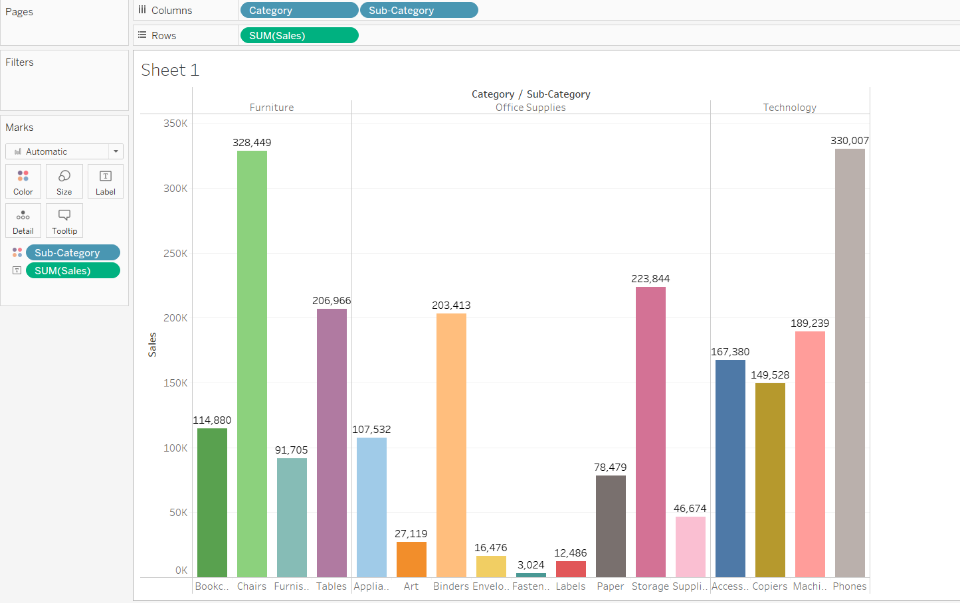

Here, Side by Side-Line chart is a good fit for given information. with this we can see that highest and lowest value of sales.

* Highest Sale = Phones(330,007)
* Lowest Sale = Fastener (3,024)

1. How do the monthly sales amounts change over the course of a year?

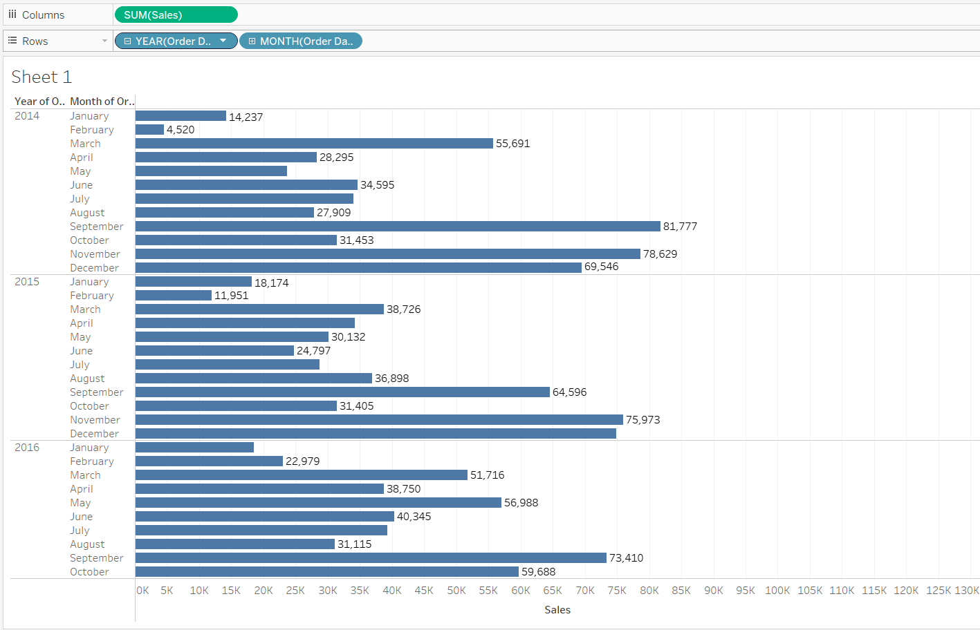 Here, the Horizontal bars chart is a good fit for given information. with this we can see the highest and lowest value of sales by month over the years.

1. How is the total sales amount distributed among different product categories?

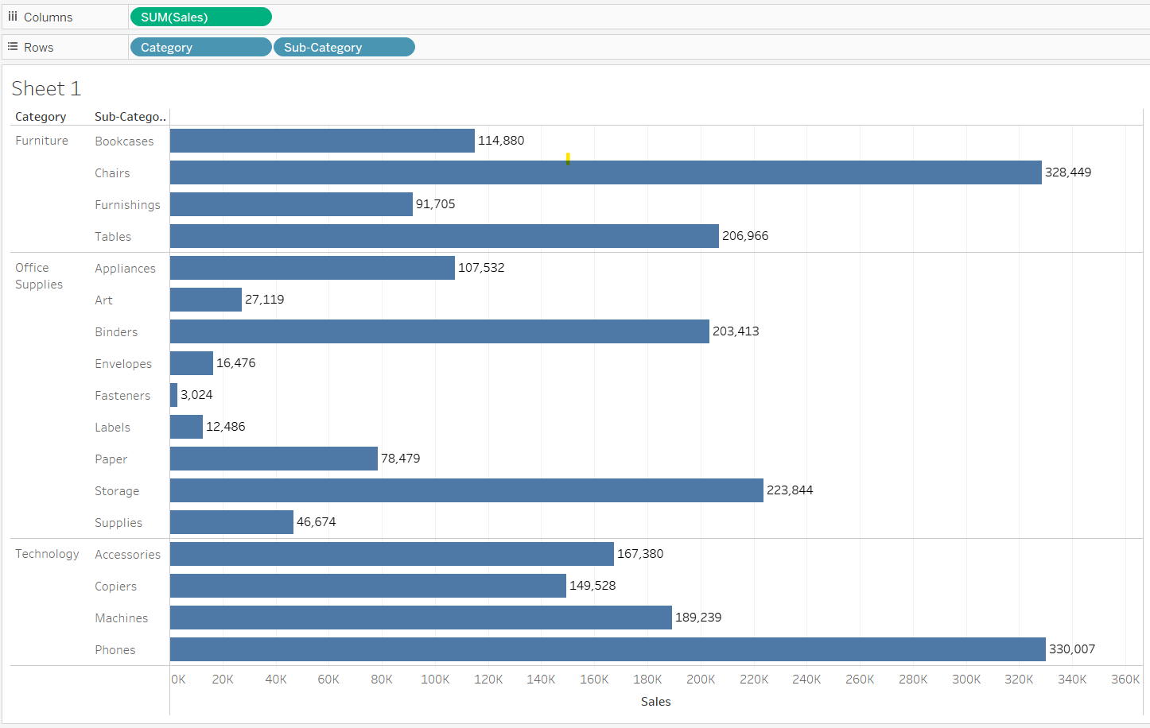

Here, the Horizontal bars chart is a good fit for given information. with this we can see the total sales amount distributed among different product categories.

1. Can we analyze the sales performance of individual customers over time?

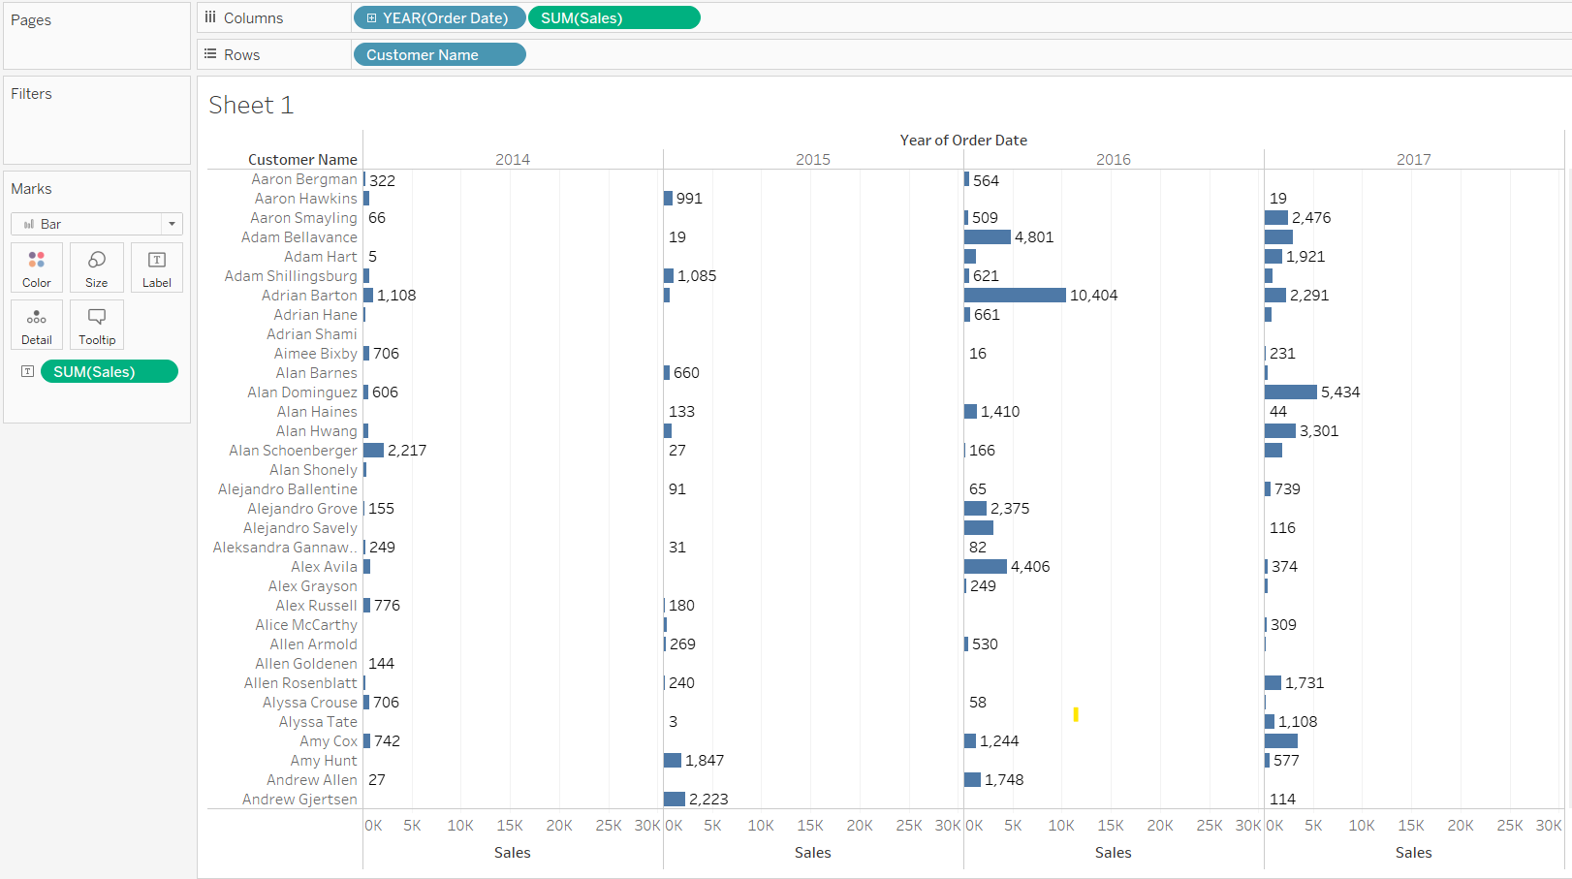

Here, the Horizontal bars chart is a good fit for given information. with this we can analyze the sales performance of individual customers over time.

1. How do sales vary based on different days of the week and product categories?

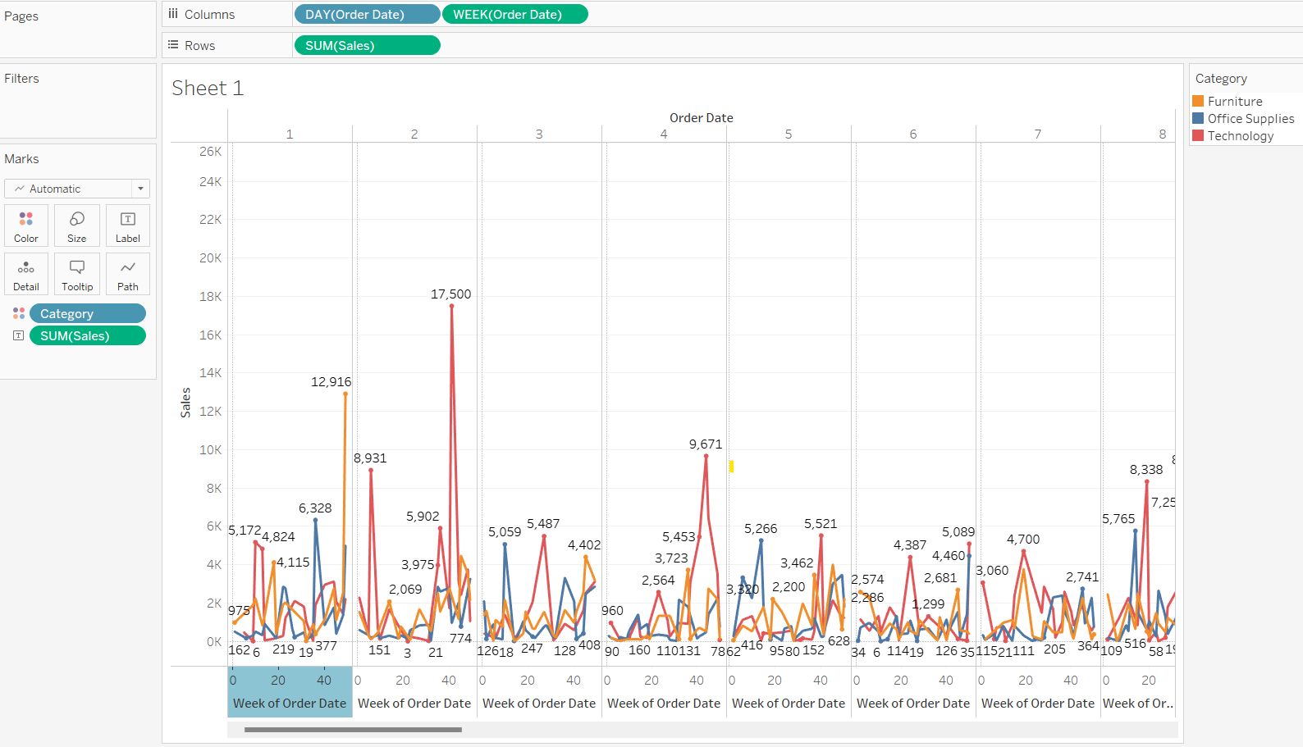

Here, the Line chart is a good fit for given information. With this we can analyze how sales vary based on different days of the week and product categories.

1. Can we visualise the sales growth of different product categories over time?

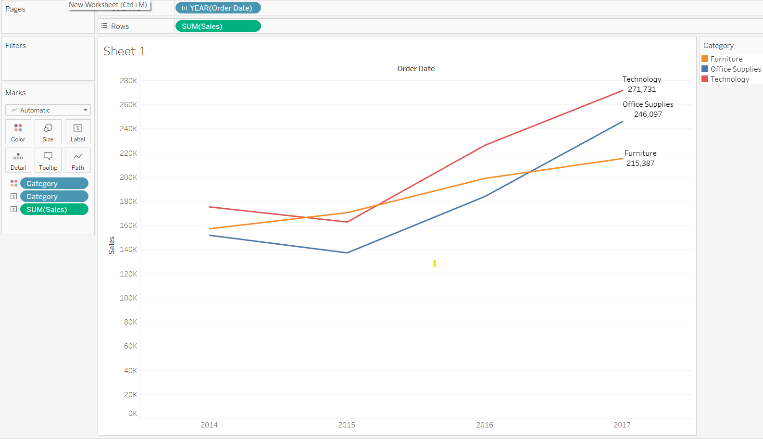

Here, the Line chart is a good fit for given information. With this we can analyze sales growth of different product categories over time. Here line chart is good because for analyze growth **over time** is easy to understand by **line chart.**

1. How does the sales distribution vary across different regions in the "Superstore" dataset?

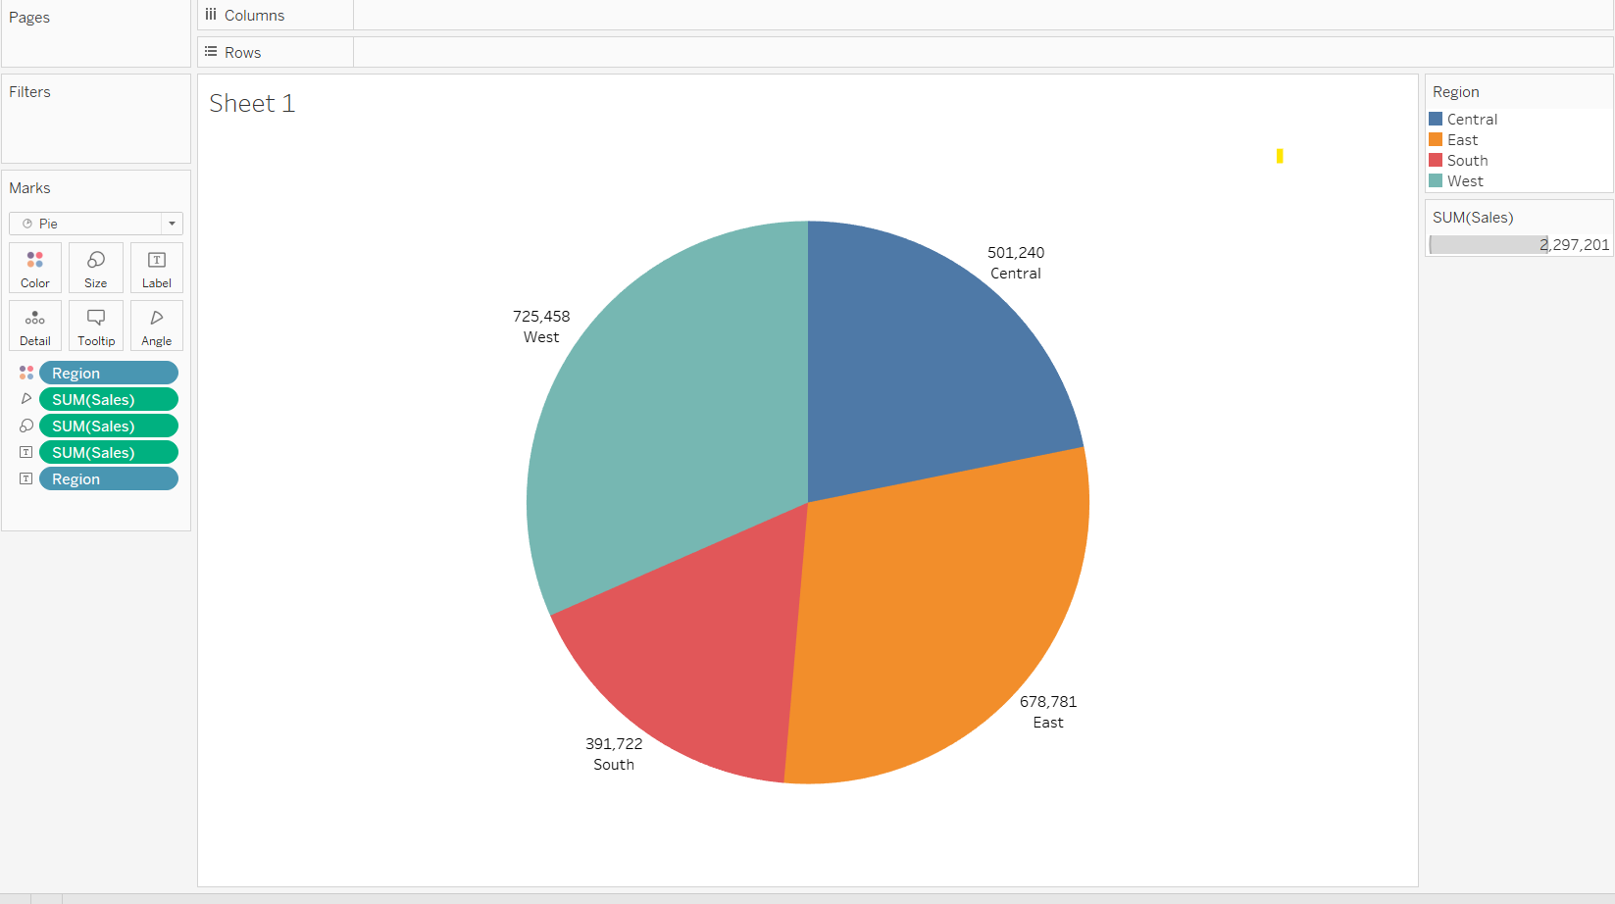

By using Pia Chart we can analyze sales distribution vary across different regions.

1. Can we visualise the composition of profits across various subcategories within different customer segments?

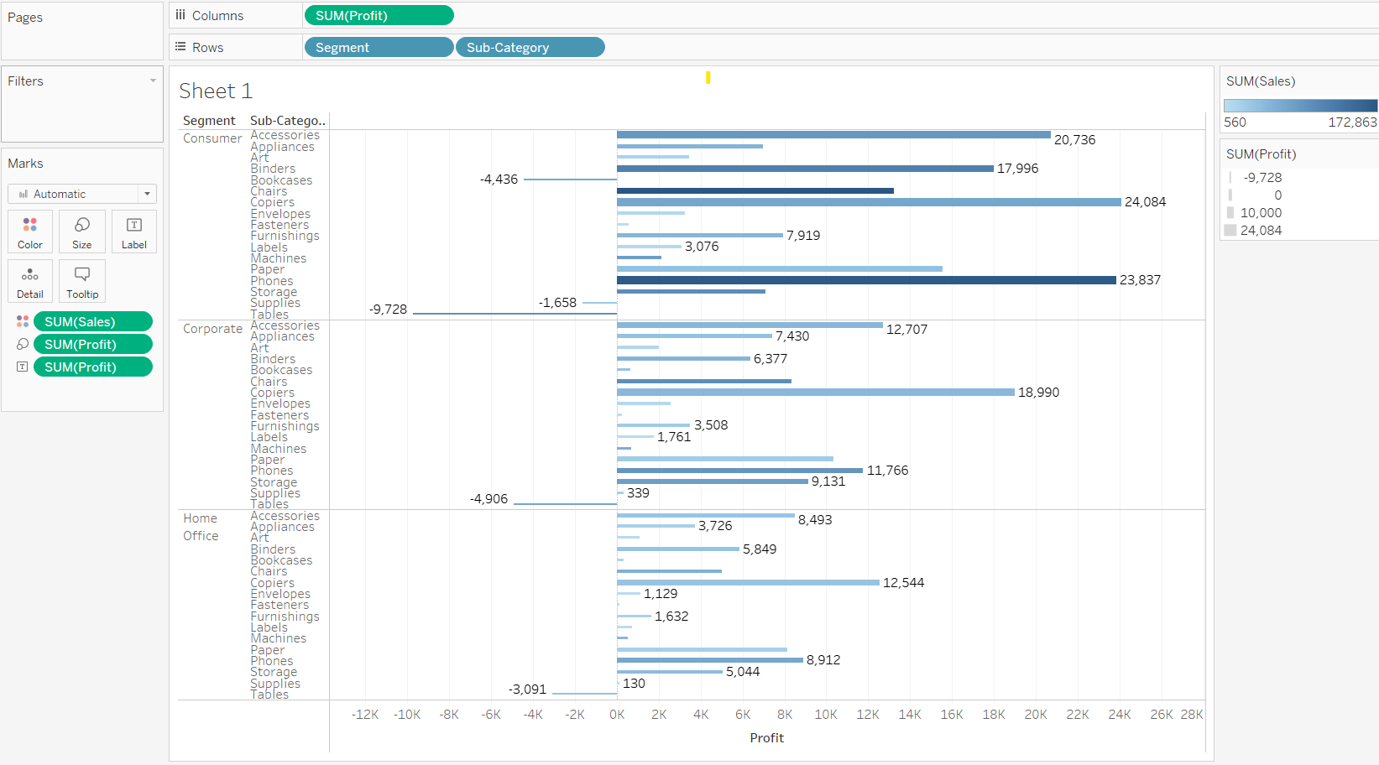

Here, the Line chart is a good fit for given information. With this we can analyze and visualise the composition of profits across various subcategories within different customer segments.

1. What is the percentage contribution of each region to the overall sales?

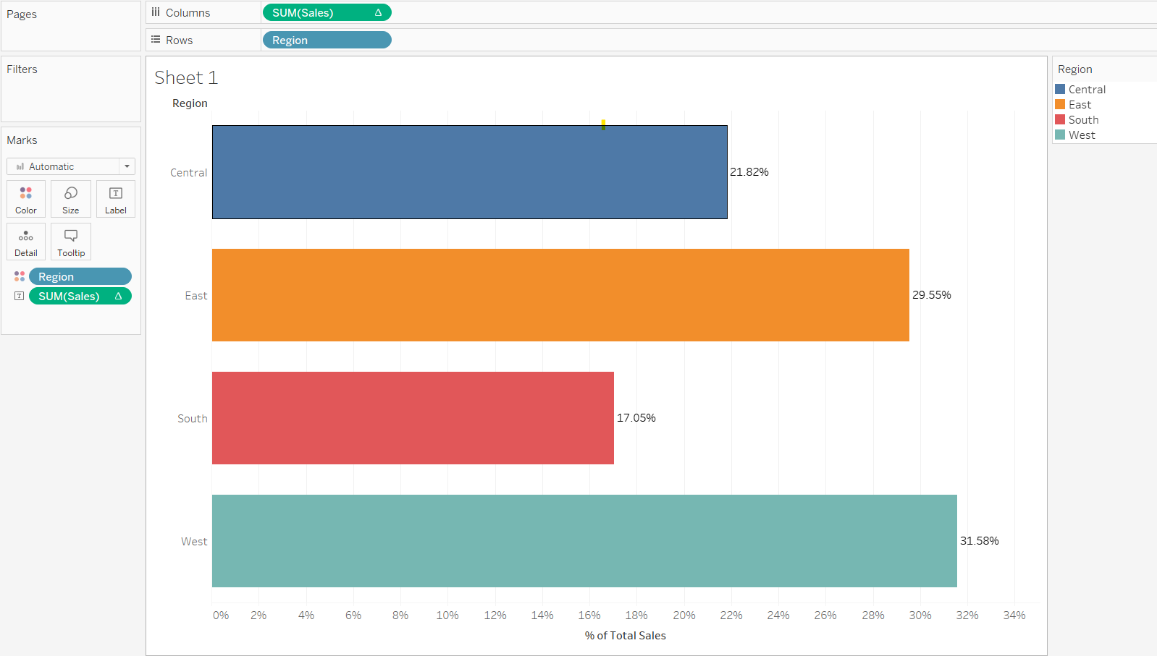

Here, the Line chart is a good fit for given information. With this we can analyze and visualise the percentage contribution of each region to the overall sales.

1. Can we visualise the profit margins associated with different shipping modes and customer segments?

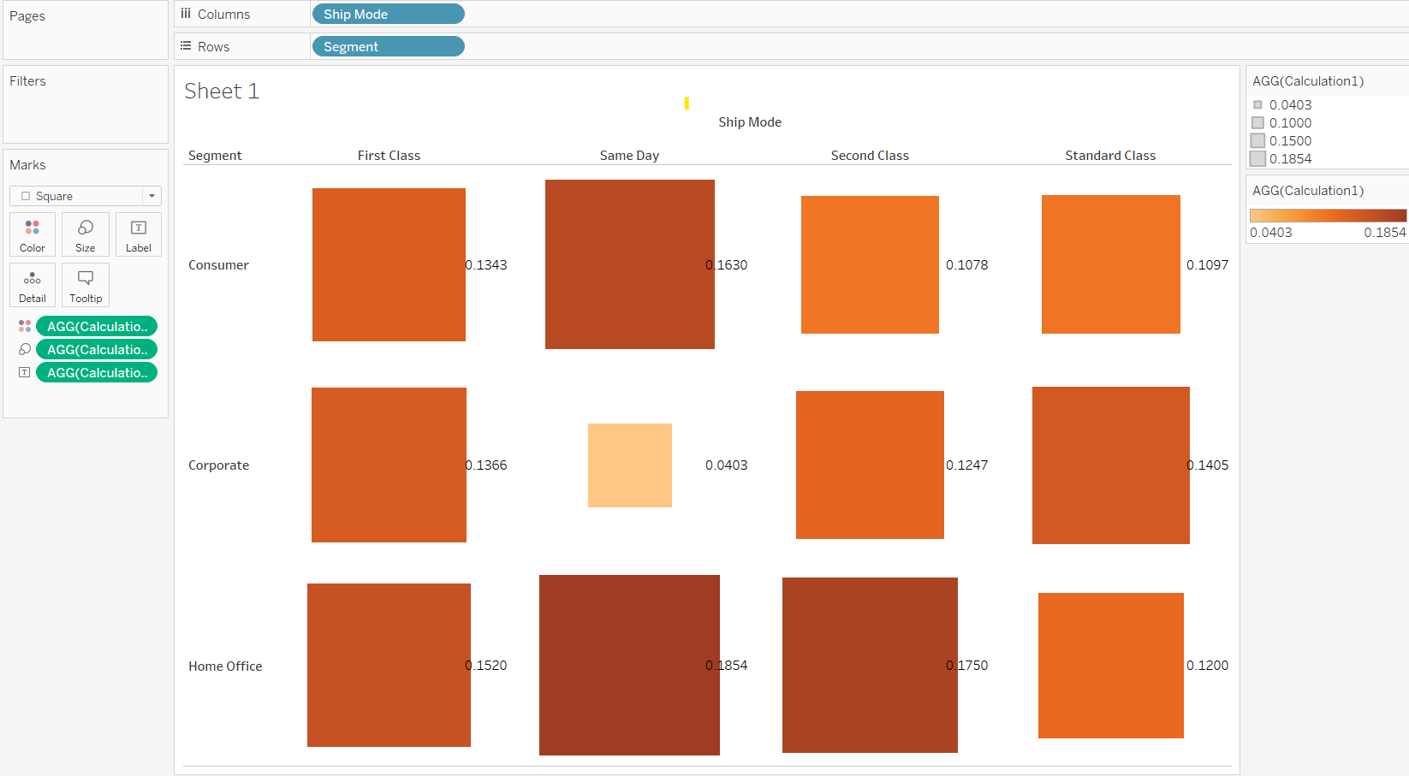

Here, the Heat maps chart is a good fit for given information. With this we can analyze and visualise the profit margins associated with different shipping modes and customer segments.

1. How long does it take to process orders for different product categories?

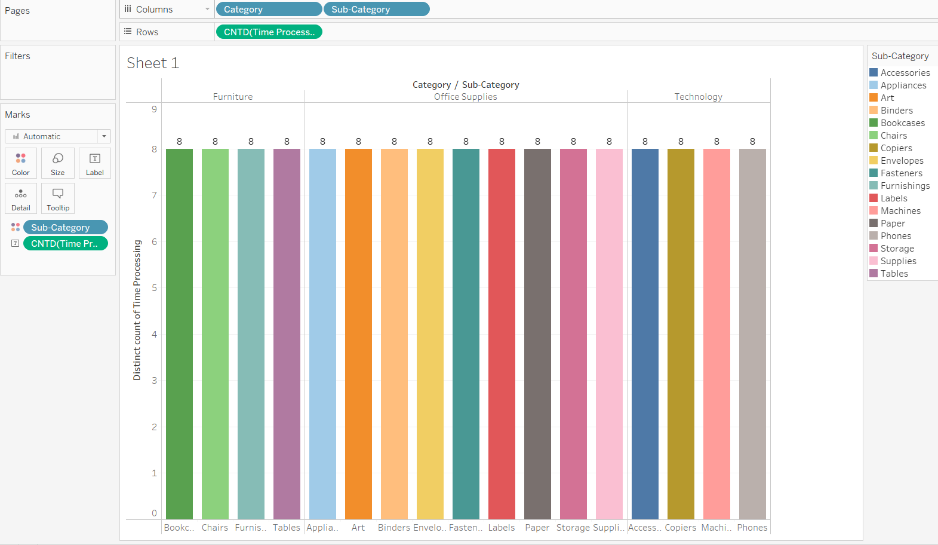

Here, the Side-by-side Bar chart is a good fit for given information. With this we can analyze and visualise the percentage contribution of each region to the overall sales.

1. How do discounts affect overall profit?

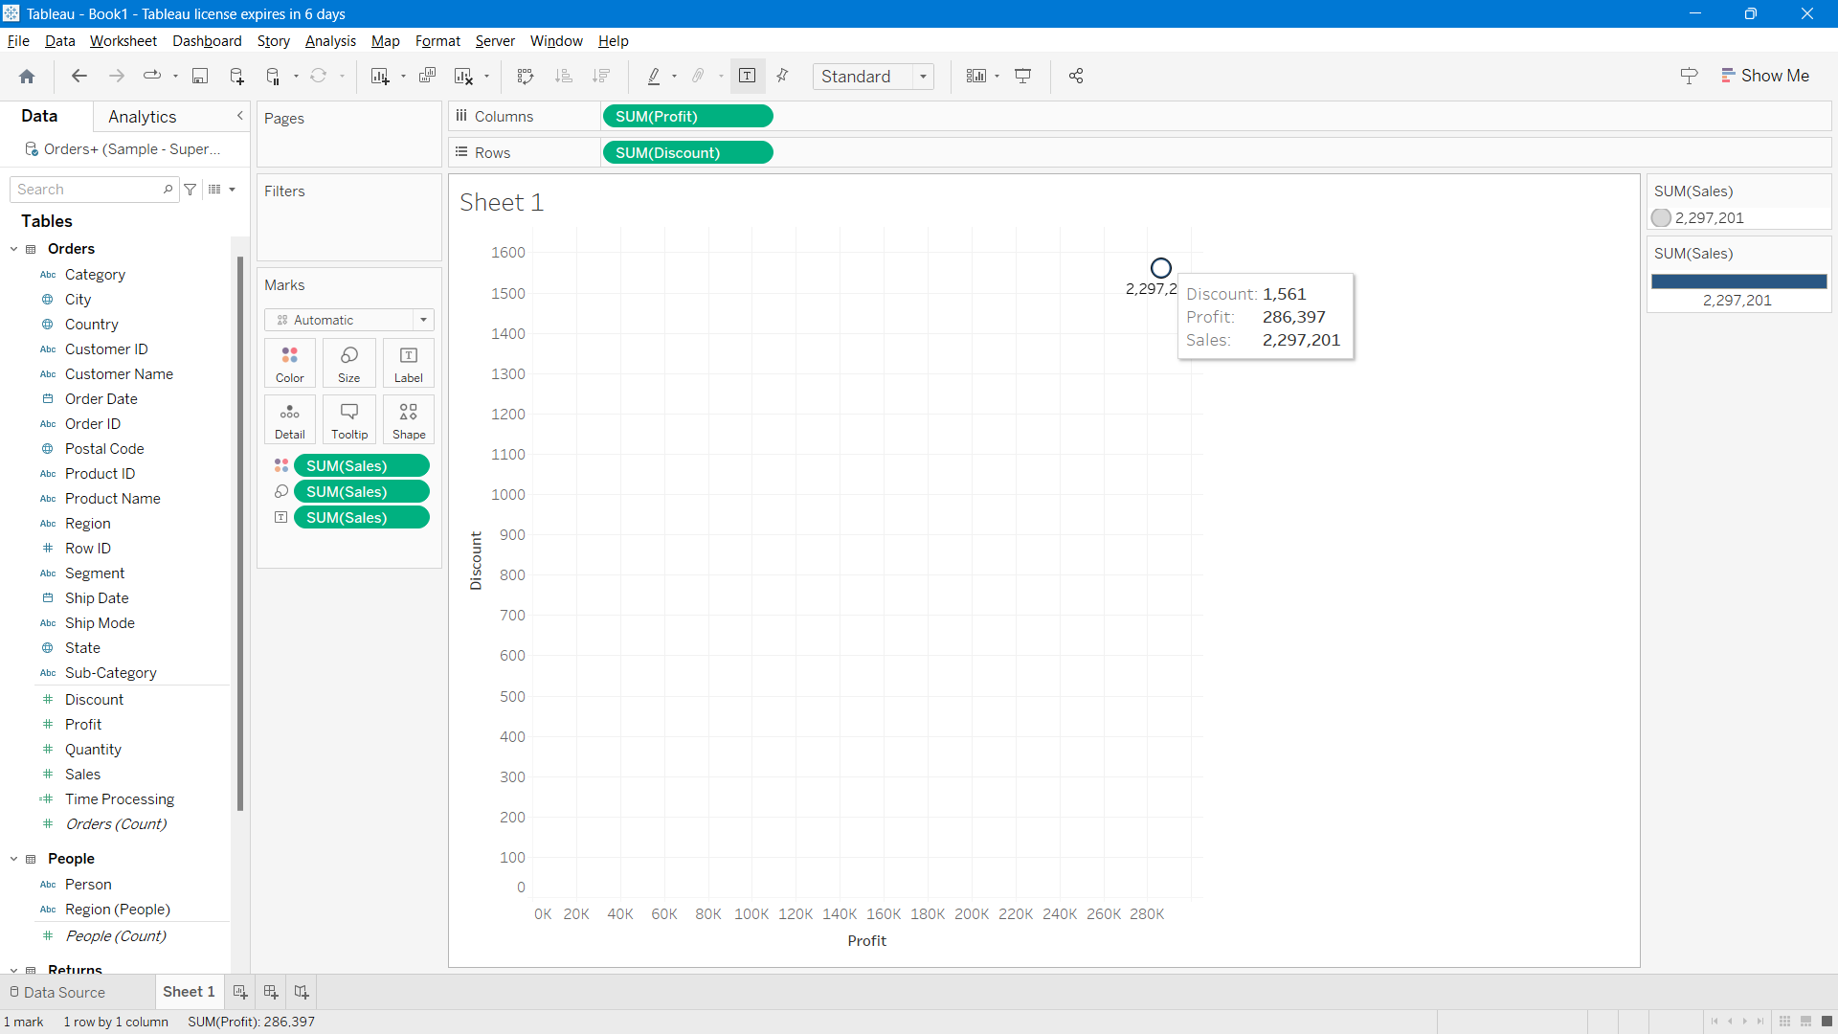

Here, the Side-by-side Bar chart is a good fit for given information. With this we can analyze and visualise discounts affect overall profit.

1. Can we visualise the relationship between product sales and profitability for different product categories?

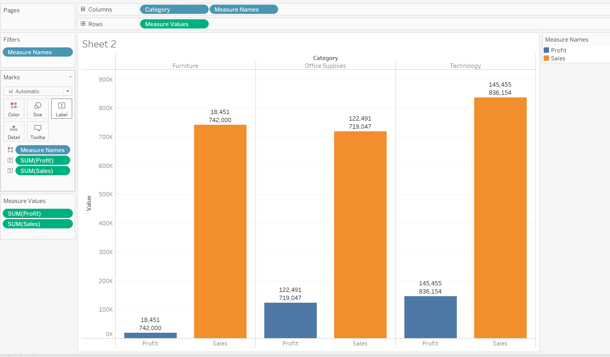

Here, the Side-by-side Bar chart is a good fit for given information. With this we can analyze and visualise relationship between product sales and profitability for different product categories.

1. What is the distribution of order quantities for products in the dataset?

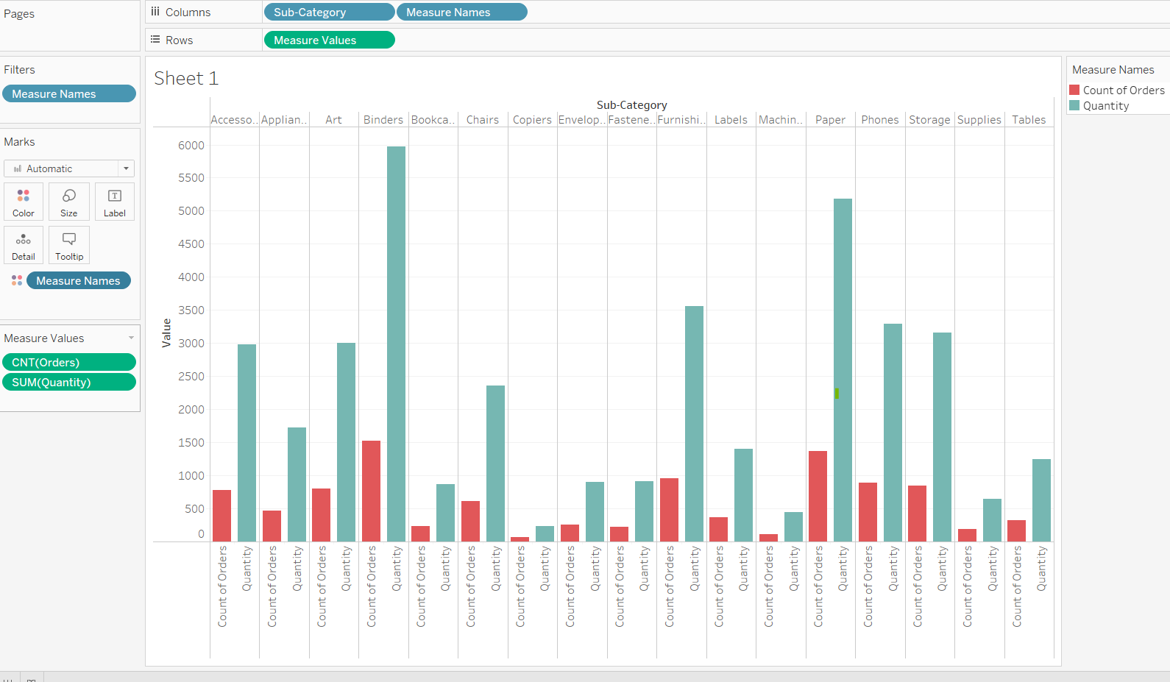

Here, the Side-by-side Bar chart is a good fit for given information. With this we can analyze and visualise the distribution of order quantities for products.

1. How do the profit distributions vary across different product categories?

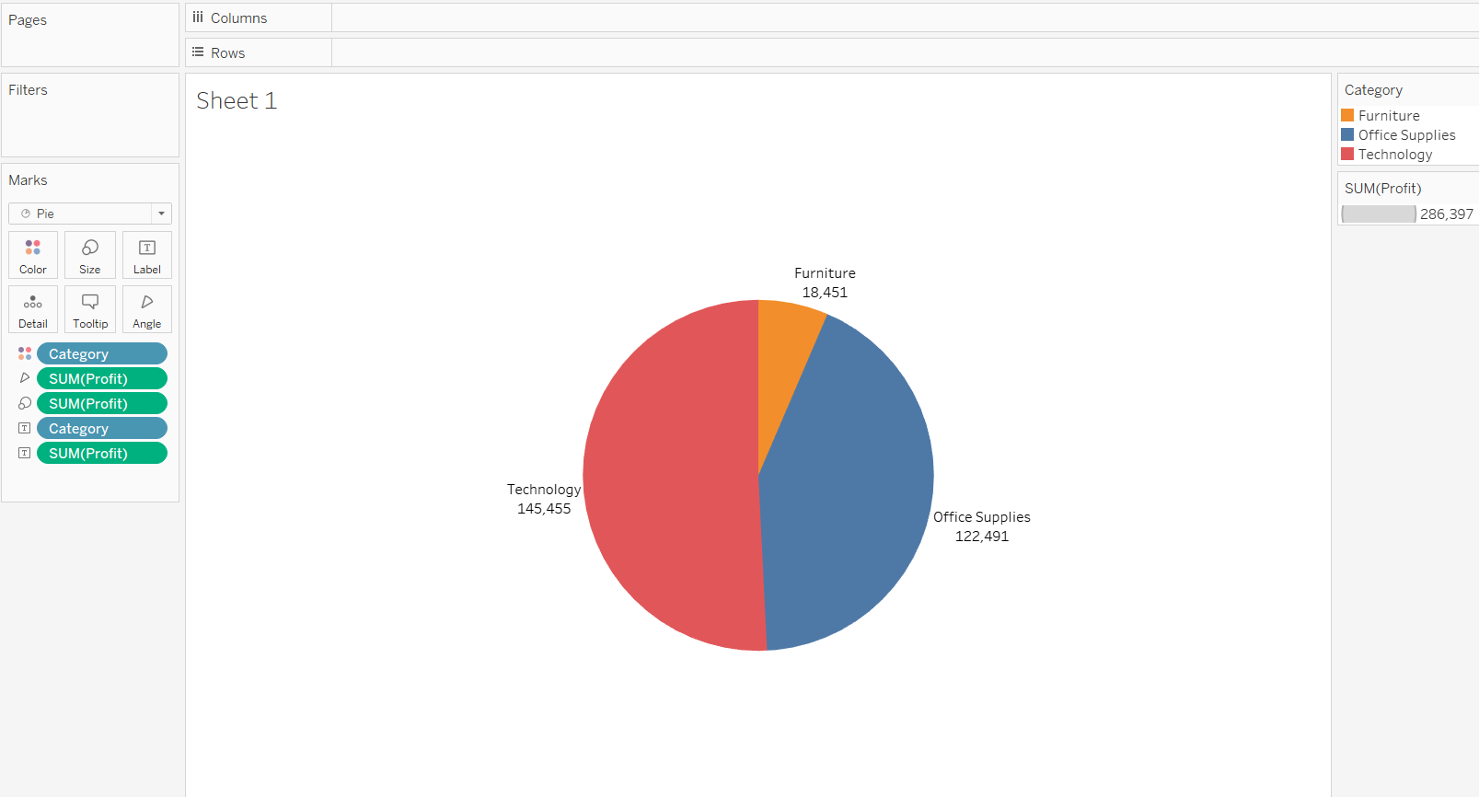

Here, the Pia chart is a good fit for given information. With this we can analyze and visualise the profit distributions vary across different product categories.

1. Can we compare the shipping time distributions for different shipping modes?

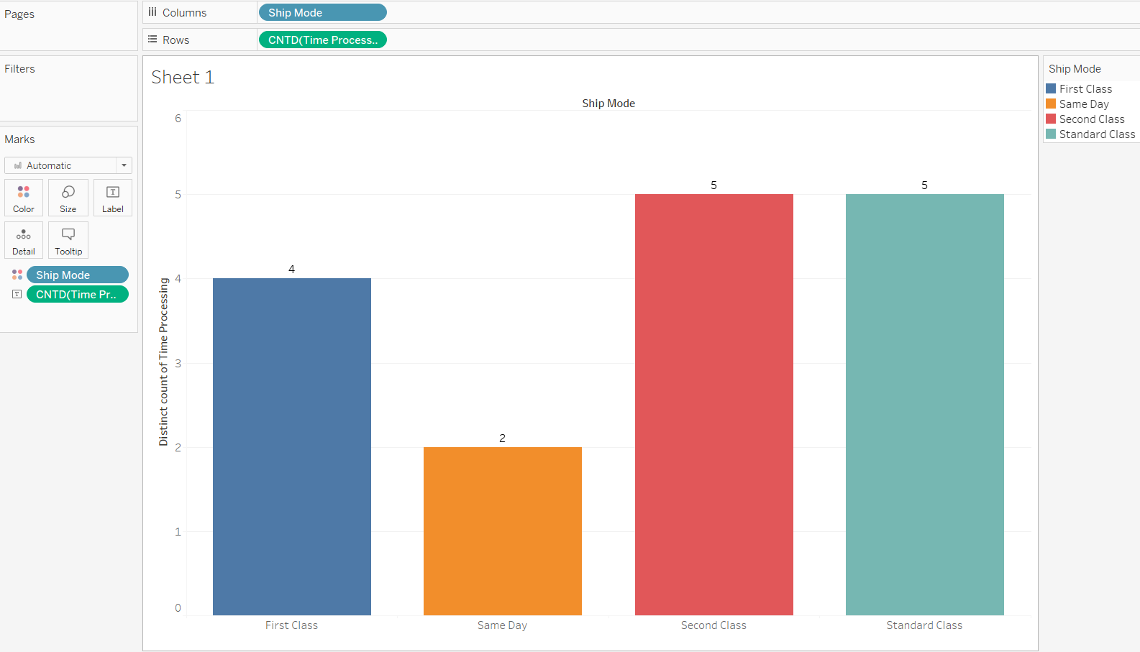

Here, the Bar chart is a good fit for given information. With this we can analyze and visualise shipping time distributions for different shipping modes.

1. What is the monthly trend in the number of orders shipped?

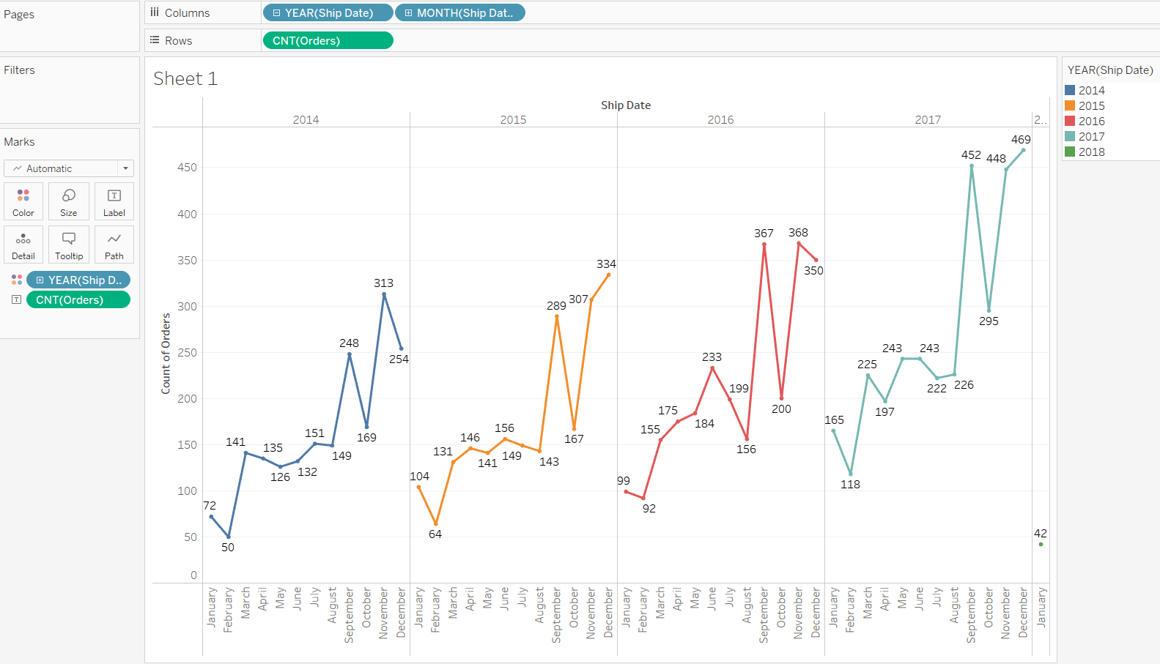

Here, the Line chart is a good fit for given information. With this we can analyze and visualise monthly trends in the number of orders shipped.

1. How do different customer segments perform in terms of sales and discount rates?

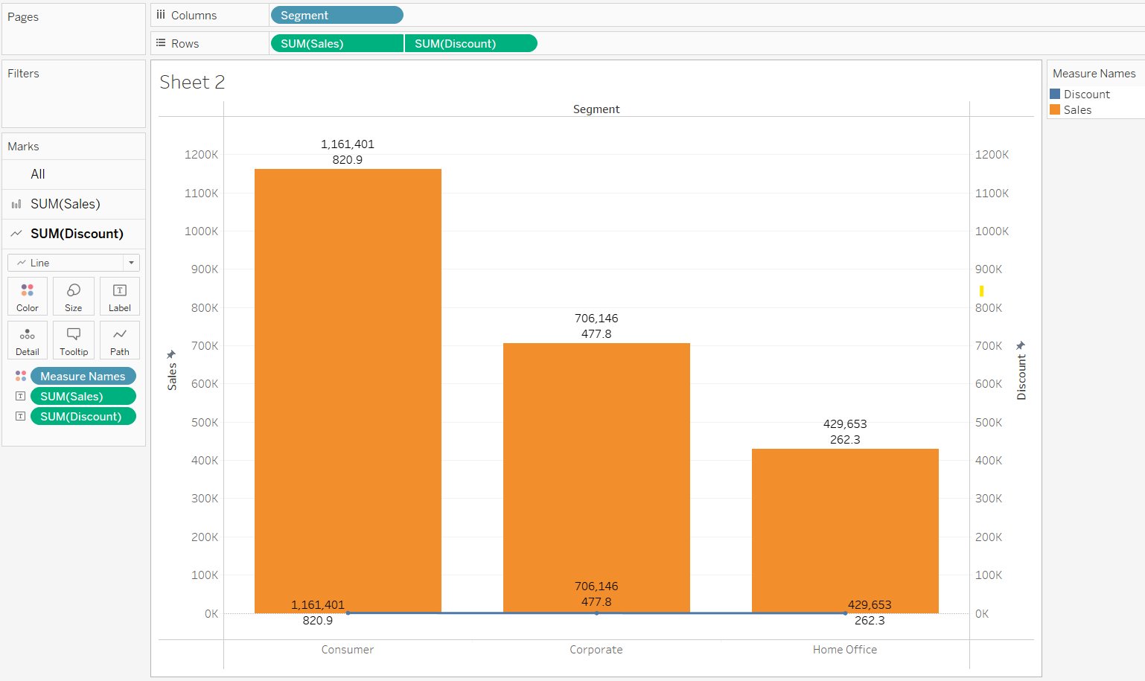

Here, the Line chart is a good fit for given information. With this we can analyze and visualise customer segments perform in terms of sales and discount rates.

1. What are the sales and profit trends across different product subcategories and regions in the Superstore dataset?

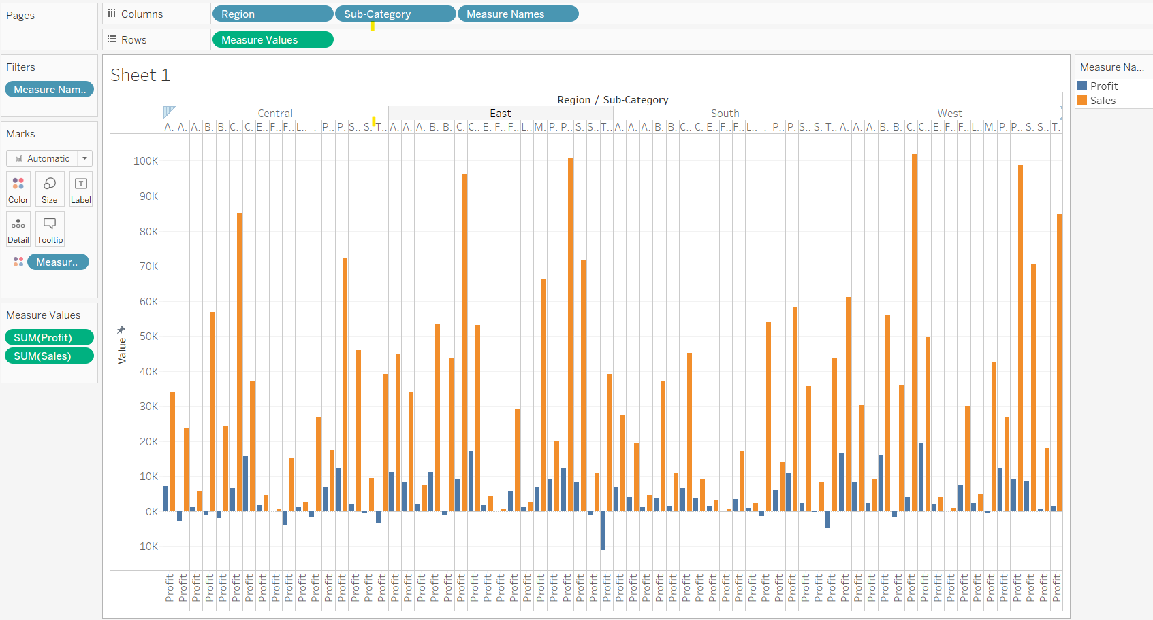

Here, the Side-by-side Bar chart is a good fit for given information. With this we can analyze and visualise sales and profit trends across different product subcategories and regions.

1. What is the average delivery duration for different regions and ship modes?

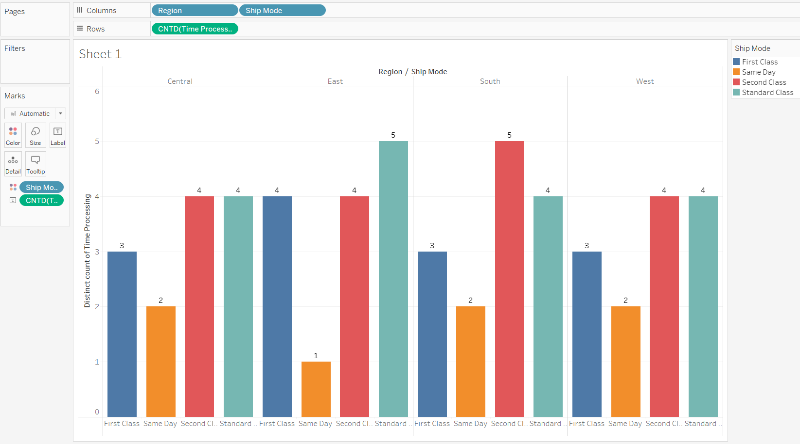

Here, the Side-by-side Bar chart is a good fit for given information. With this we can analyze and visualise average delivery duration for different regions and ship modes.

1. How has the average order quantity changed over the years for various product categories?

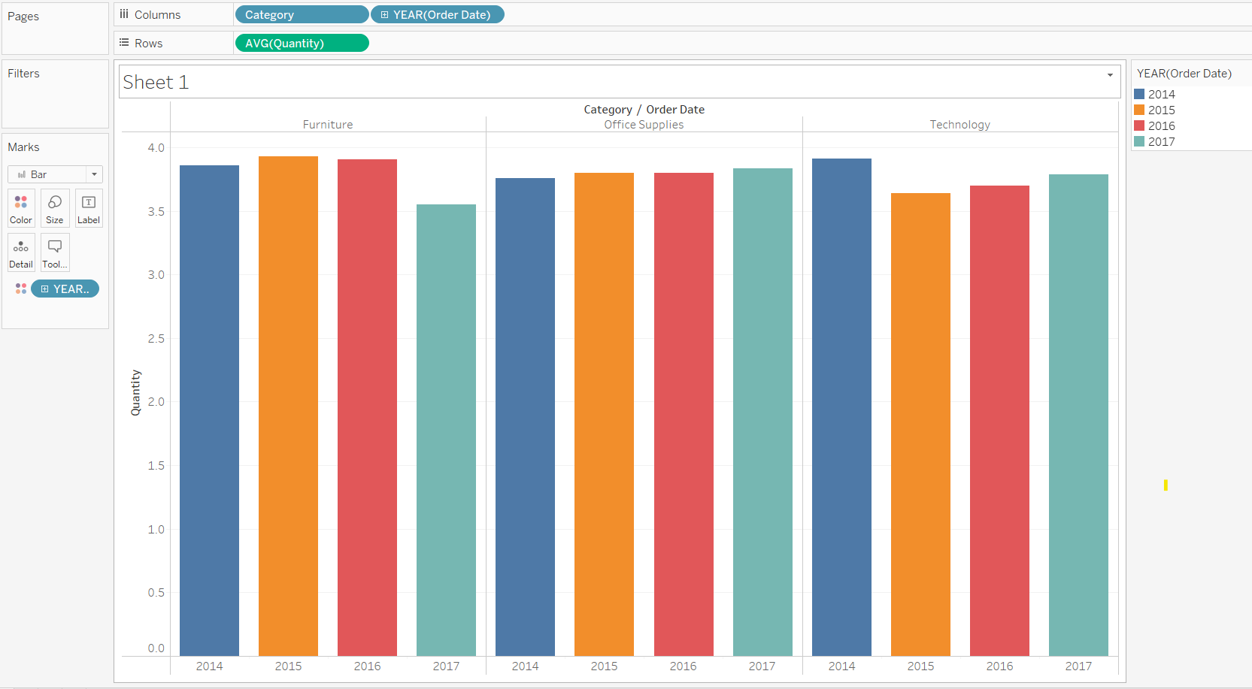

Here, the Side-by-side Bar chart is a good fit for given information. With this, we can analyze and visualise average order quantity changes over the years for various product categories.

1. Can we visualise the correlation between discount rates and order quantities for different customer segments?

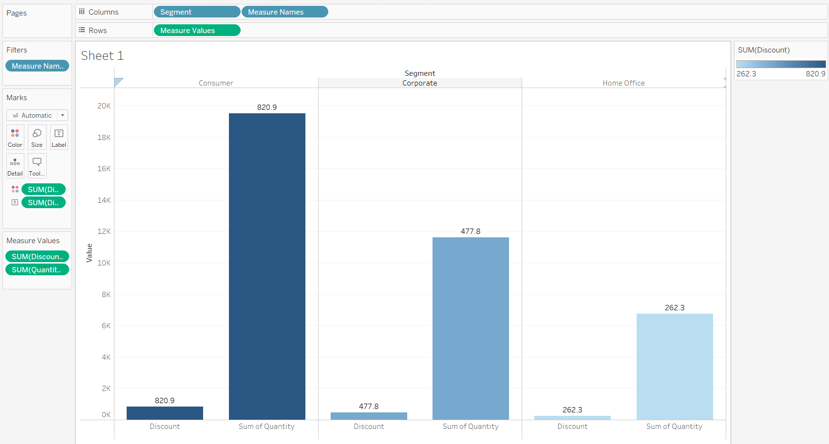

Here, the Side-by-side Bar chart is a good fit for given information. With this, we can analyze and visualise correlation between discount rates and order quantities for different customer segments.

1. What is the proportion of orders returned in each region within the Superstore dataset?

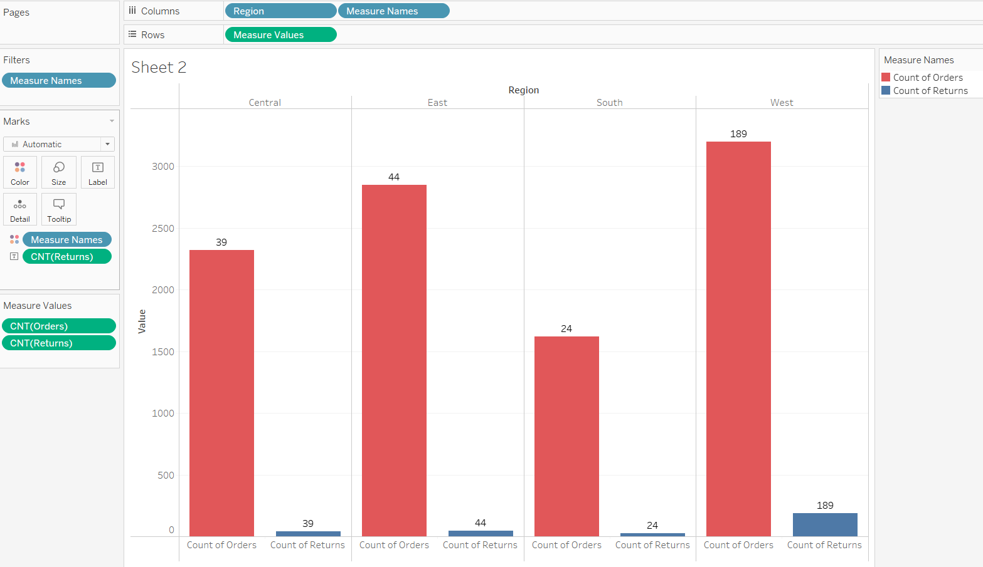

Here, the Side-by-side Bar chart is a good fit for given information. With this, we can analyze and visualise orders returned in each region.

1. Can you compare the profit of different products for different subcategories?

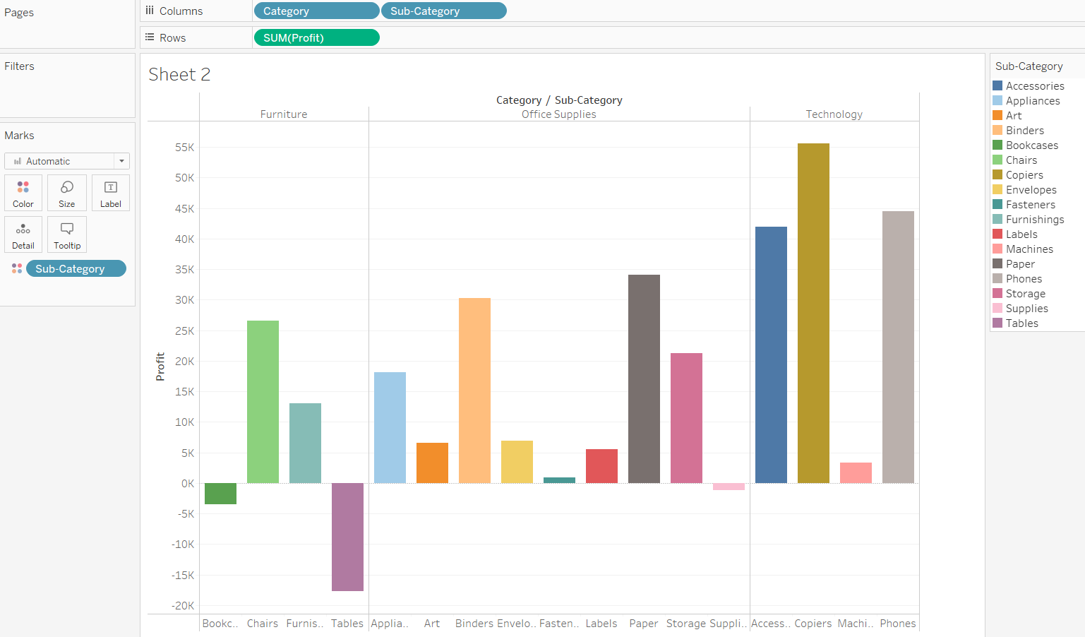

Here, the Side-by-side Bar chart is a good fit for given information. With this, we can analyze and visualise profit of different products for different subcategories.

1. Which shipping mode is the most commonly used in the Sample Superstore dataset?

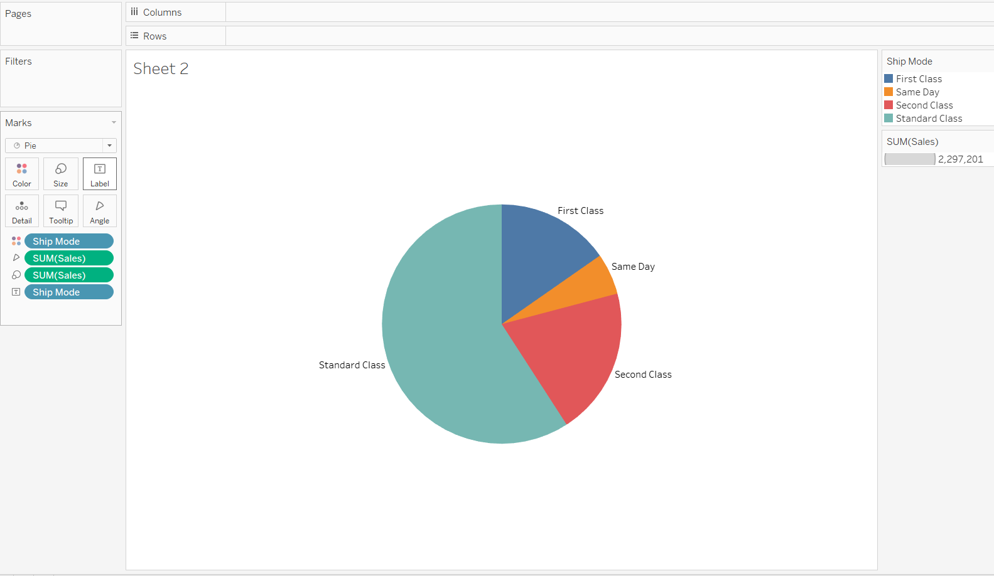

Here, the Pia chart is a good fit for given information. With this, we can analyze and visualise First Class shipping mode is the most commonly used.

1. How does the sales performance of different regions evolve throughout the quarters of a year?

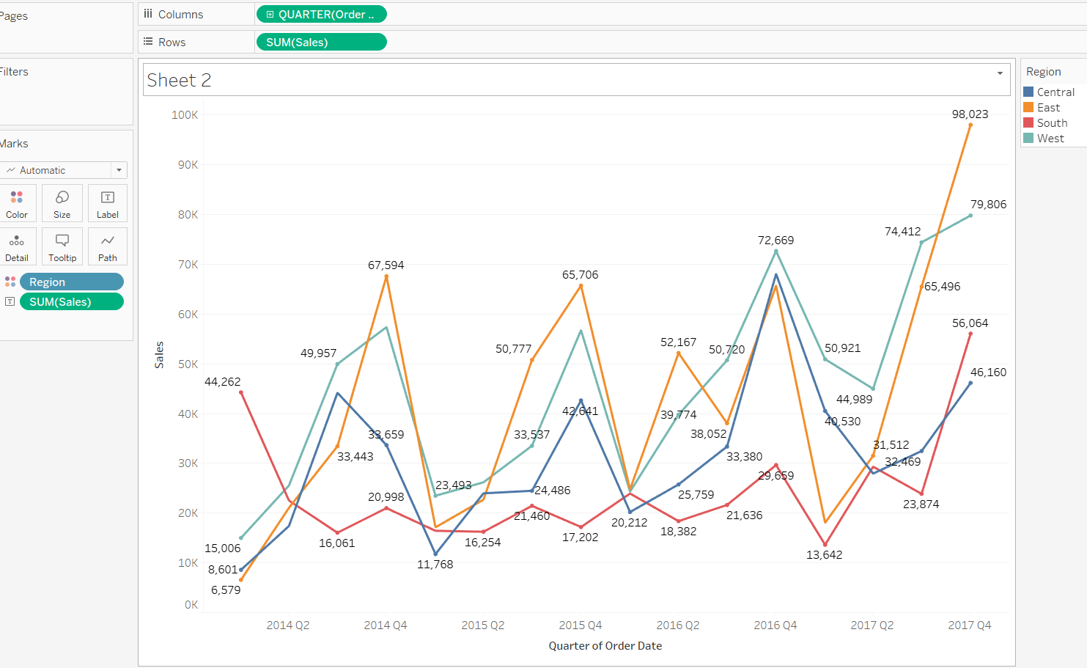

Here, the Line chart is a good fit for given information. With this, we can analyze and visualise sales performance of different regions evolve throughout the quarters of a year.

1. What is the distribution of order priorities across different product categories?

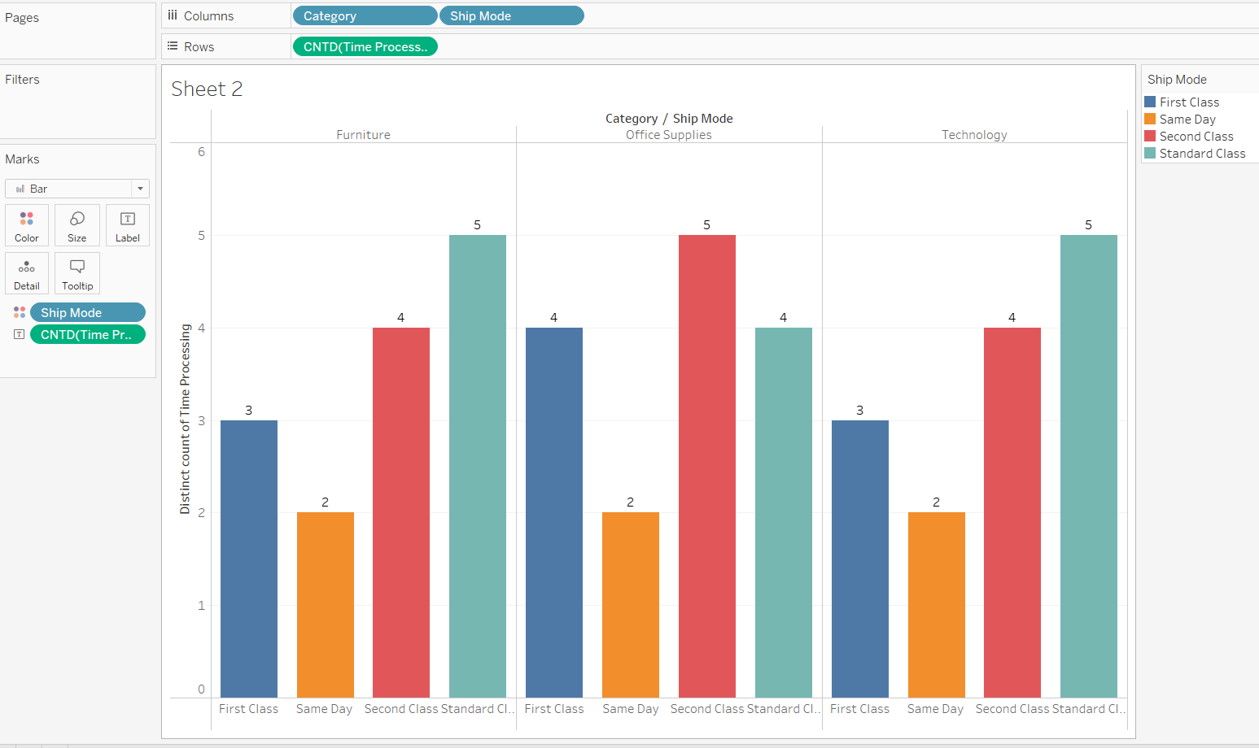

Here, the Side-by-Side Line chart is a good fit for given information. With this, we can analyze and visualise distribution of order priorities across different product categories.

1. What is the relationship between discounts and sales?

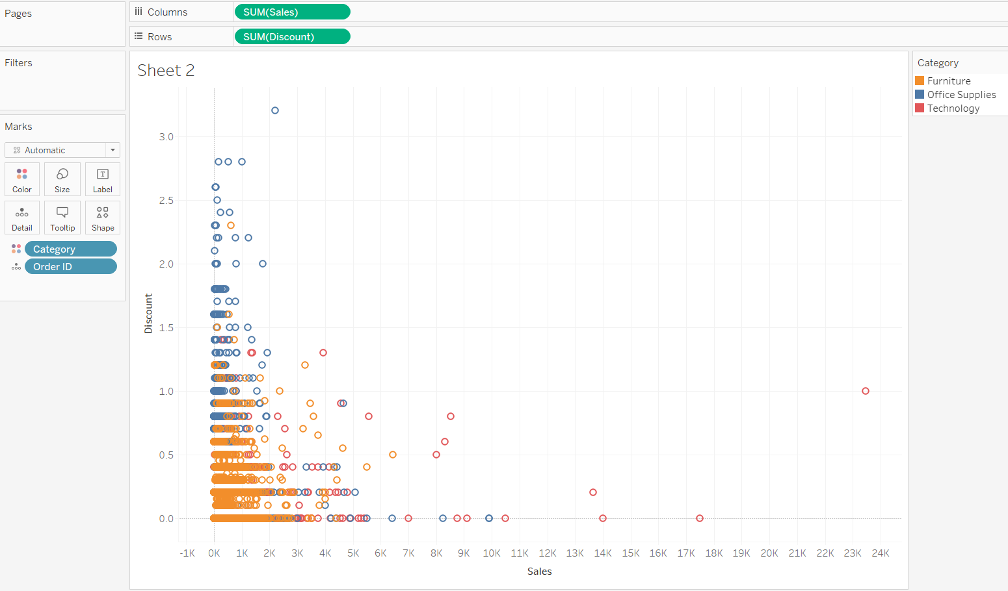

Here, the scatter plot chart is a good fit for given information. With this, we can analyze and visualise relationship between discounts and sales.

1. How does the average order value differ between repeat customers and new customers?

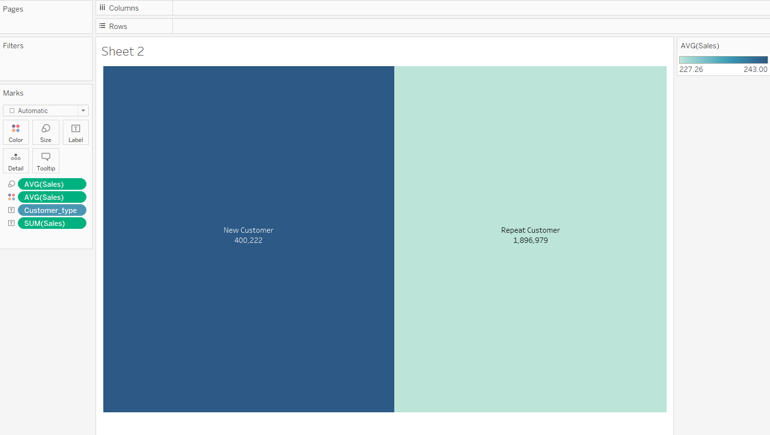

Here, the Tree map chart is a good fit for given information. With this, we can analyze and visualise average order value differ between repeat customers and new customers.

1. What is the geographical distribution of returns and its impact on overall profitability?

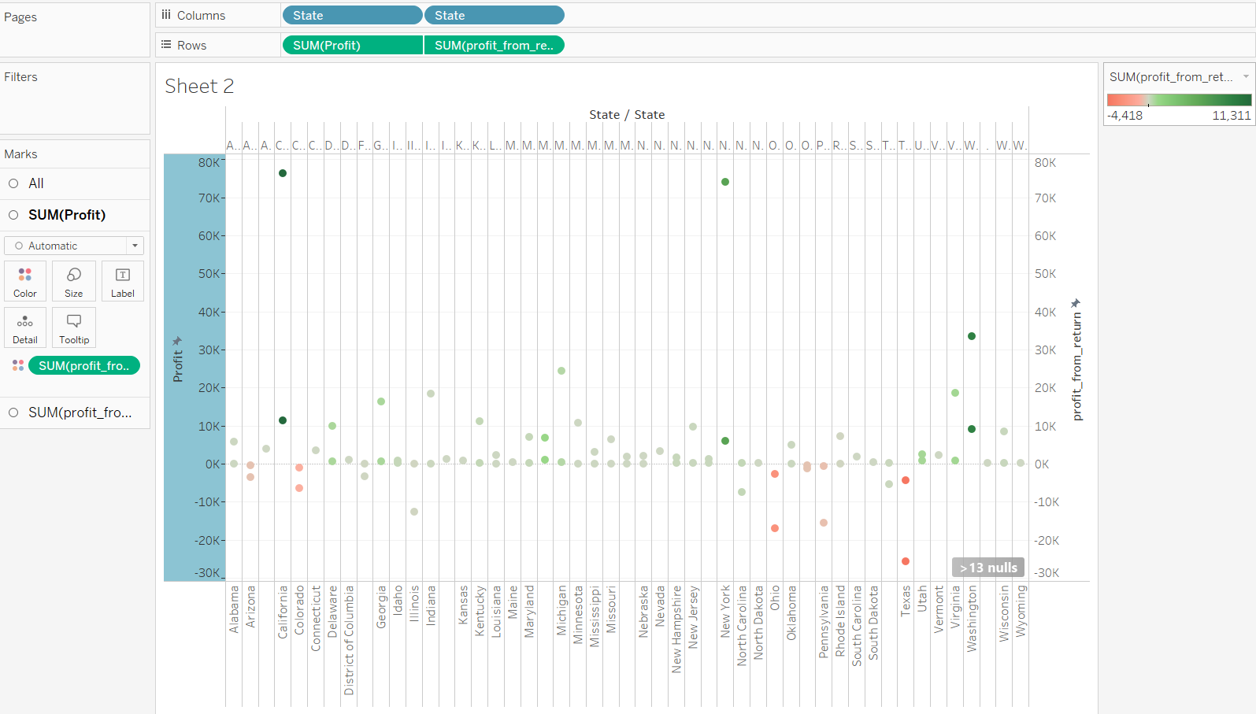

Here, the scatter plot chart is a good fit for given information. With this, we can analyze and visualise geographical distribution of returns and its impact on overall profitability.